# Plotting simulated accuracy

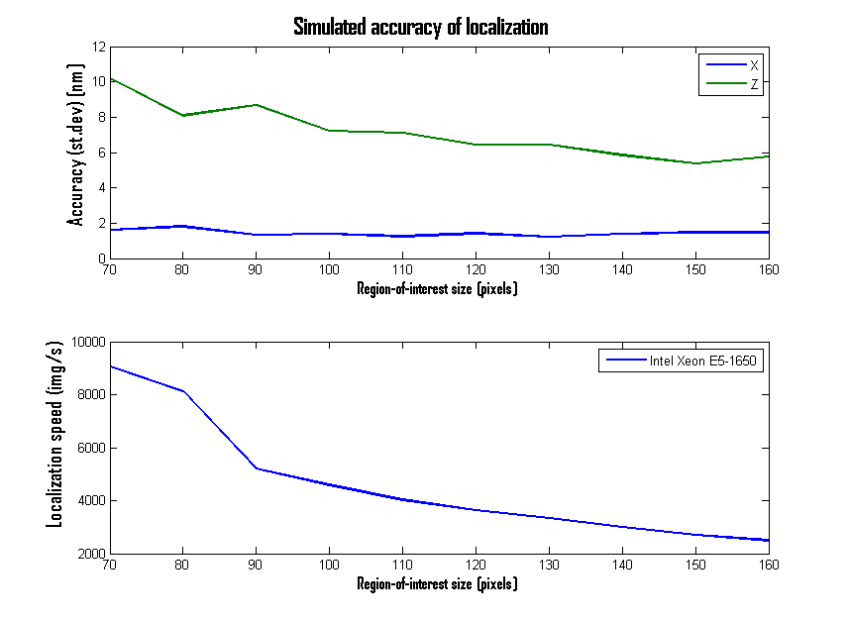

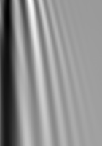

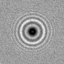

Figuur : Sample image (ROI=70)

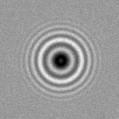

Figure : Z Lookup Table

Figure : Sample image (ROI=160)